Screen short 1.1

Search Issues Tab.

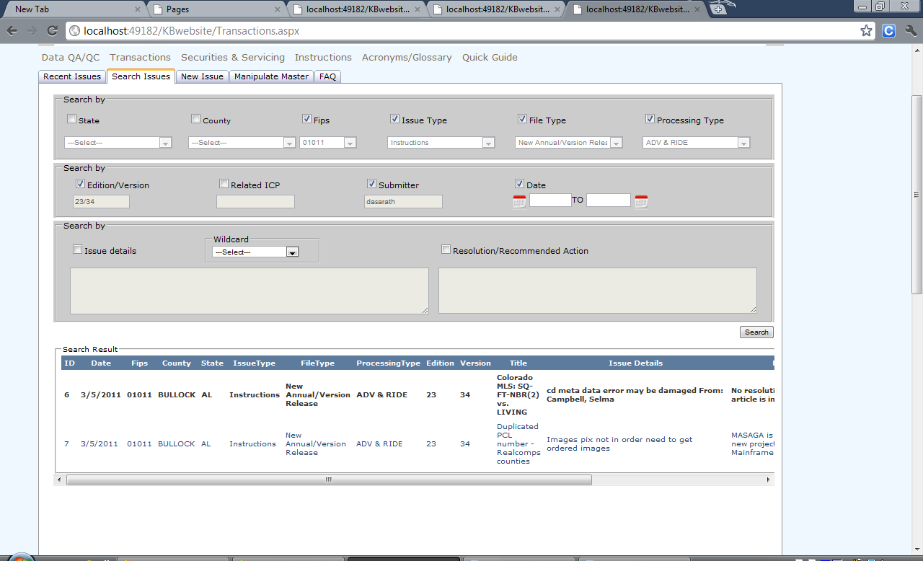

Please let me know if any changes to be done to the search Issues Tab

Screen short 1.2

Search Issues Tab.

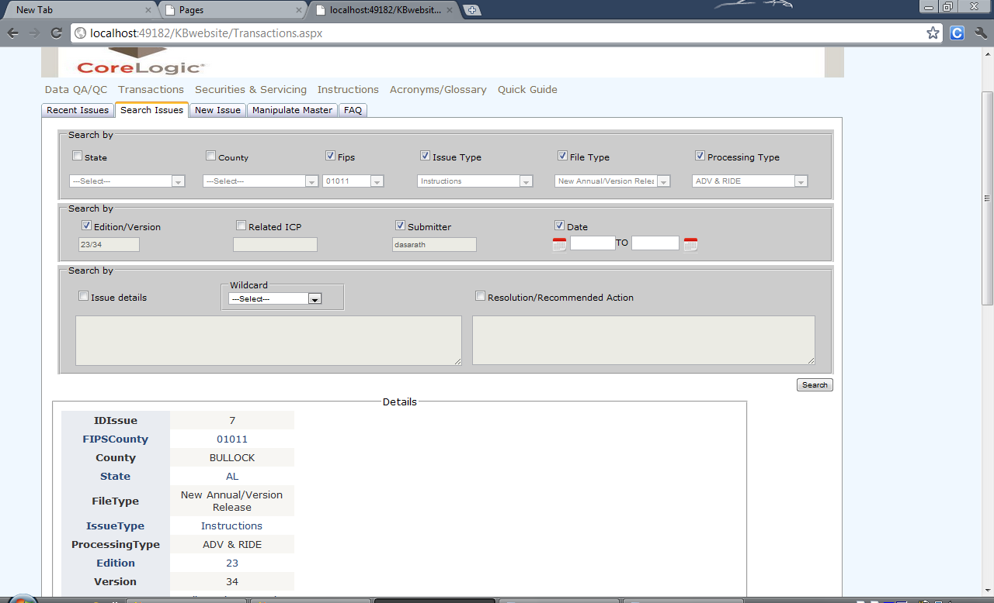

Wildcard now working for contains eg. “cd meta \*”,”[LIKE] Mapping Problem”

I will be changing the Details view to normal web form control view

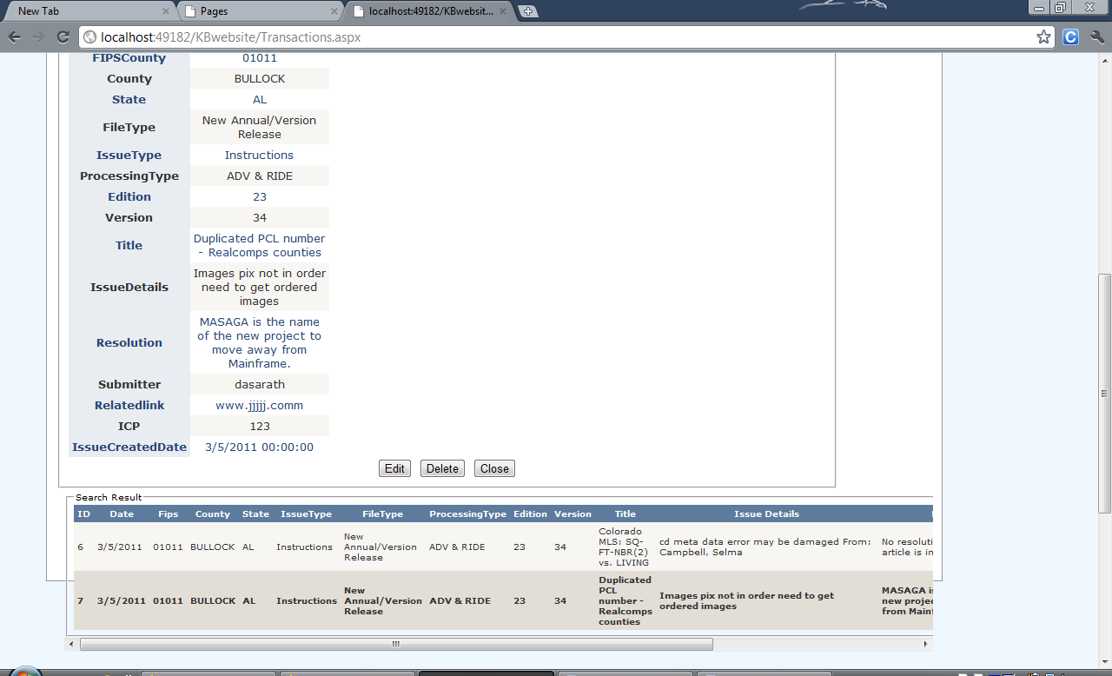

New Issues Tab

Screen Short 2.1

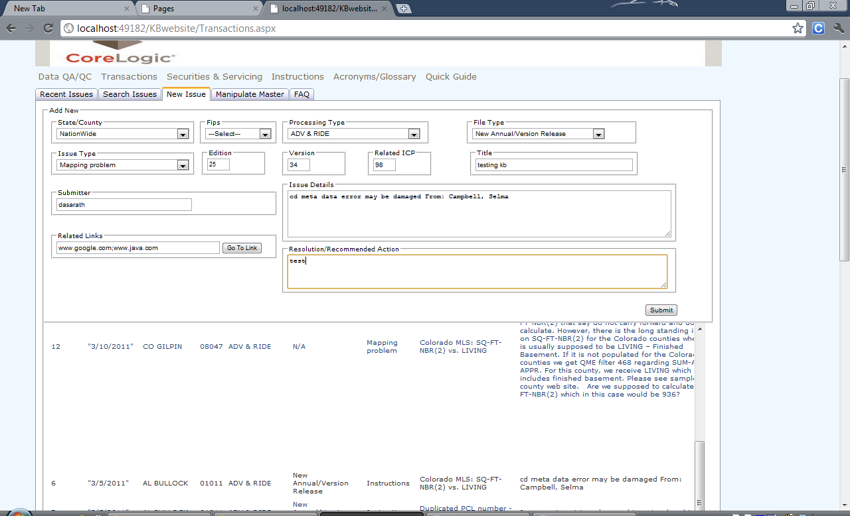

Please let me know if any changes to be done to the new Issues Tab

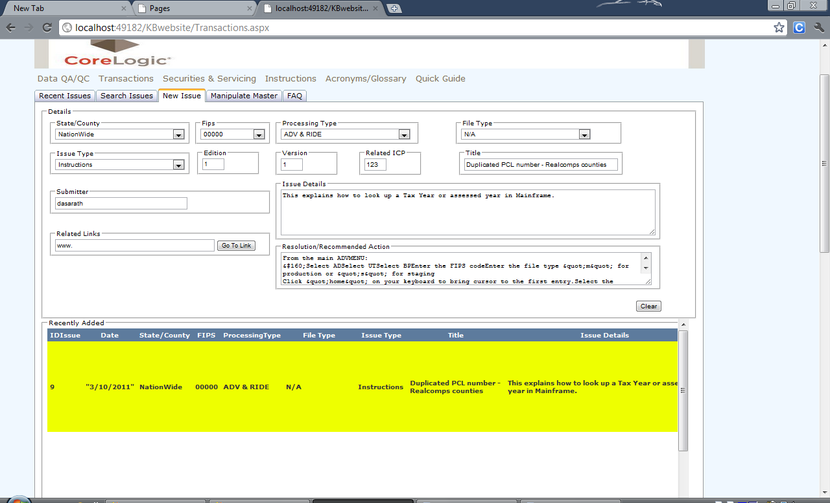

Provide d Double click in the Recently added grid view which will populate data into the controls .Please let us know if any more functionality to be added

Manipulate Master

Screen short 3.1

R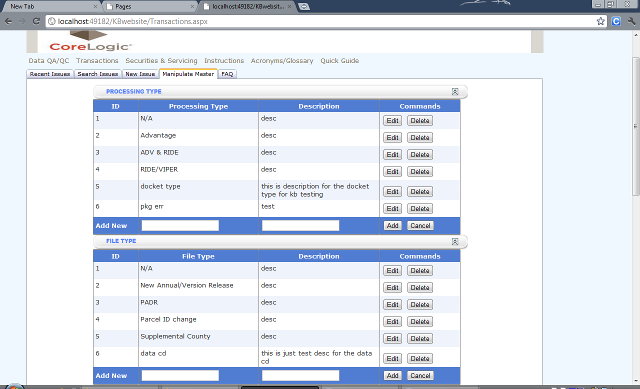

For Processing type, File Type Issue Type and Faq’s add edit delete master data

Has been provided in the Manipulate master. Let us know if any more information to add

Recent Issues Tab

Screen Short 4.1

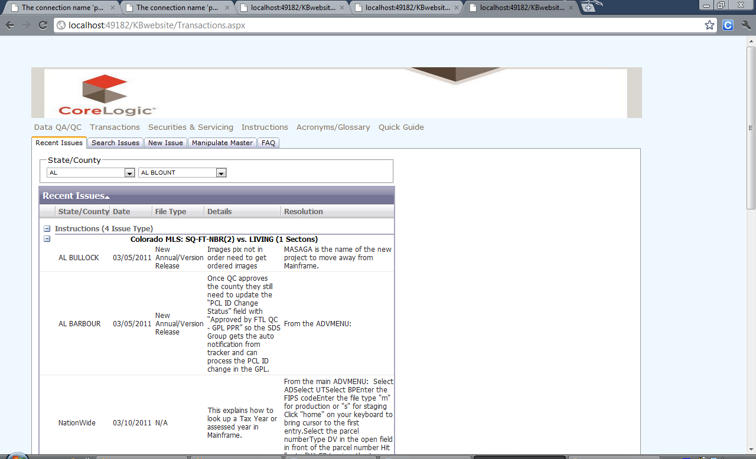

Please Let me know any changes to be done to the recent issues tab